**Project Report**

**Implementation and Evaluation of Graph Theory Algorithms**

**Design and Analysis of Algorithms**

Submitted By

Hashir Kaleem Khan (17K-3948)

Muhammad Owais (17K-3940)

**ABSTRACT**

The problem is to implement, Prims, Kruskal, Dijkstra, Bellman Ford, FloydWarshall Algorithm and Clustering Coefficient in Graph Theory using the input files provided.

**INTRODUCTION**

The Prims, Kruskal, Dijkstra, Bellman Ford, FloydWarshall Algorithm should be implemented using the input files provided. Input file contains the coordinates to be plotted using graphs. It also contains the data about the nodes that are connected to each other. First the data is extracted properly then from that extracted data adjacency matrix is made. After adjacency matrix, all the above algorithms are implemented. The first algorithm is Prims which finds a minimum spanning tree for a weighted undirected graph. The second algorithm is Kruskal finds a [minimum spanning tree](https://en.wikipedia.org/wiki/Minimum_spanning_tree) for a [connected](https://en.wikipedia.org/wiki/Connectivity_(graph_theory)) [weighted graph](https://en.wikipedia.org/wiki/Glossary_of_graph_theory#Weighted_graphs_and_networks) adding increasing cost arcs at each step. The third is Bellman Ford which finds the shortest path between a given source vertex and all other vertices in the graph. The fourth is Dijkstra which finds the shortest paths between nodes in a graph. The fifth is FloydWarshall Algorithm which is used for finding shortest paths in a weighted graph with positive or negative edge weights.

**FLOW DIAGRAM**

First input should be selected which file to use from input10 to input100. It will prompt for which algorithm to choose after choosing it will display the output as well as the graph for that algorithm.

**EXPERIMENTAL SETUP**

This system is based on C++ which used graphics.h library for plotting graphs. First the system will ask you to select how much inputs you want to take from 10-100 for 10 enter “1”, for 20 enter “2” till 90 same procedure should be used. For 100 inputs use “0”.

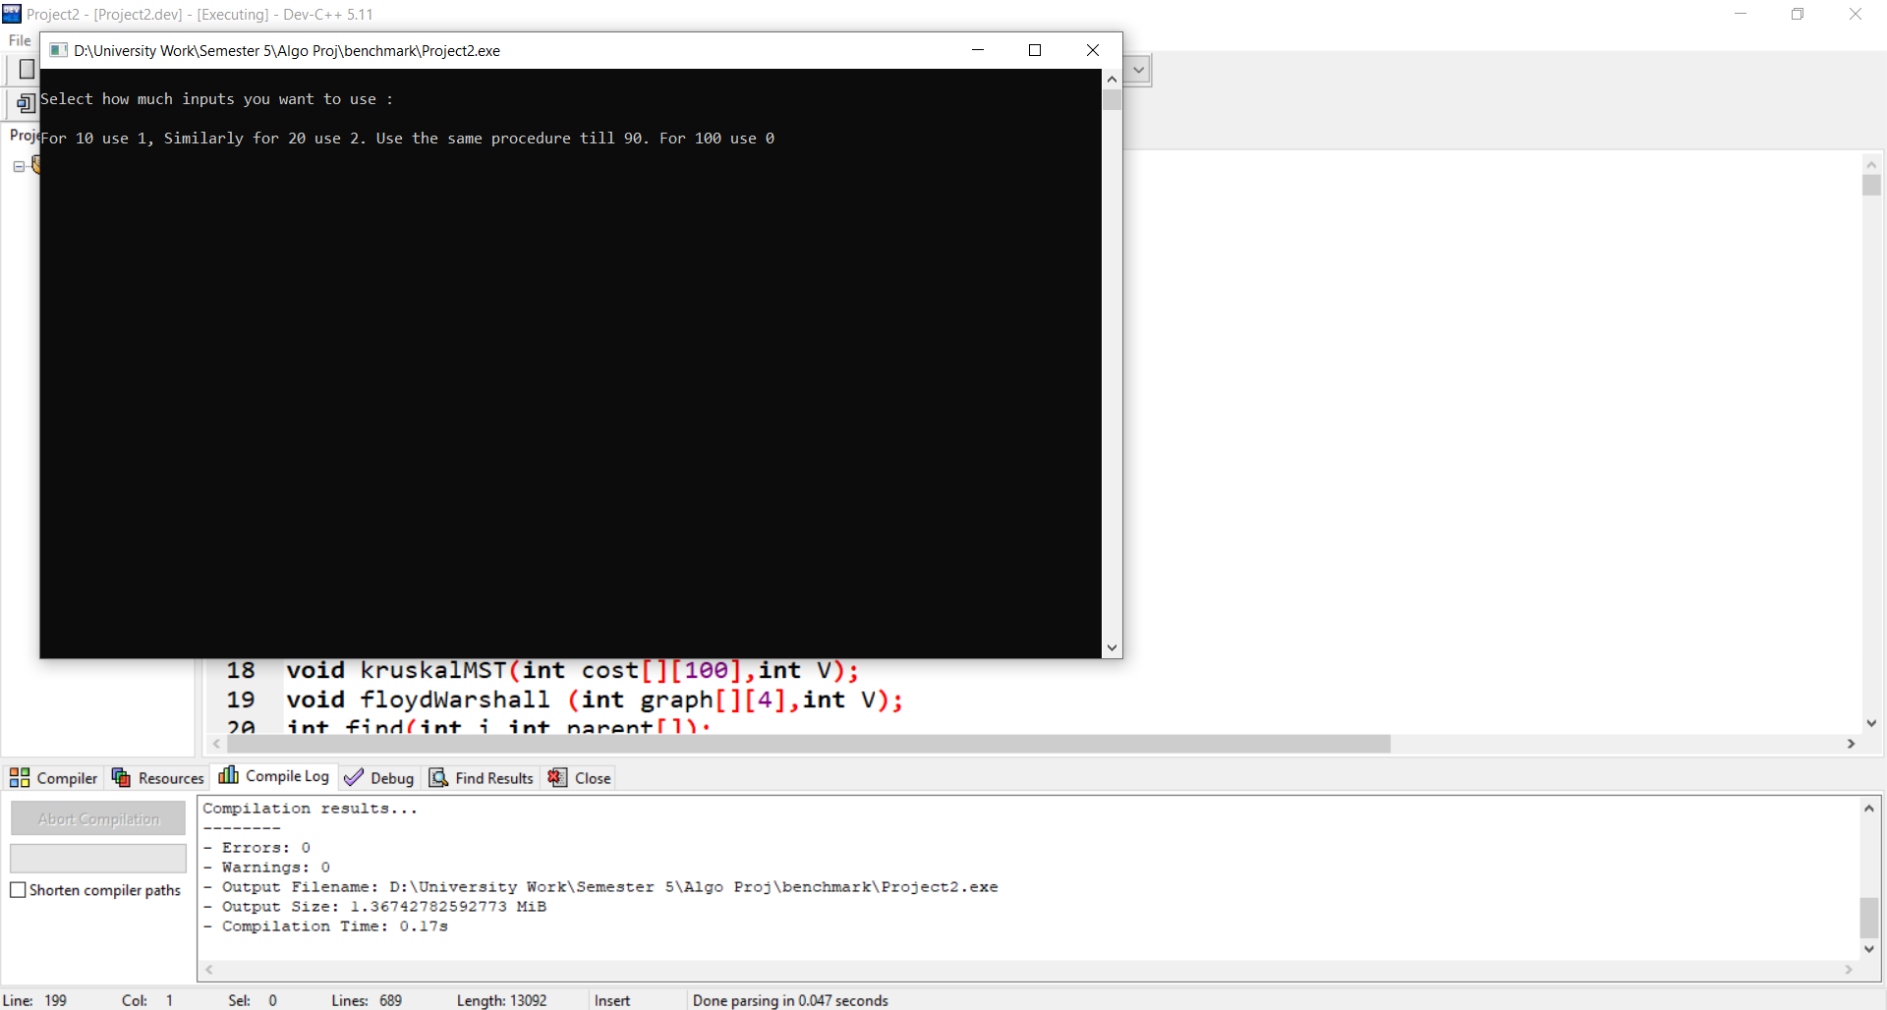

Then it will show the nodes x and y coordinates and connected nodes and distances.

After that it will ask which algorithm to implement 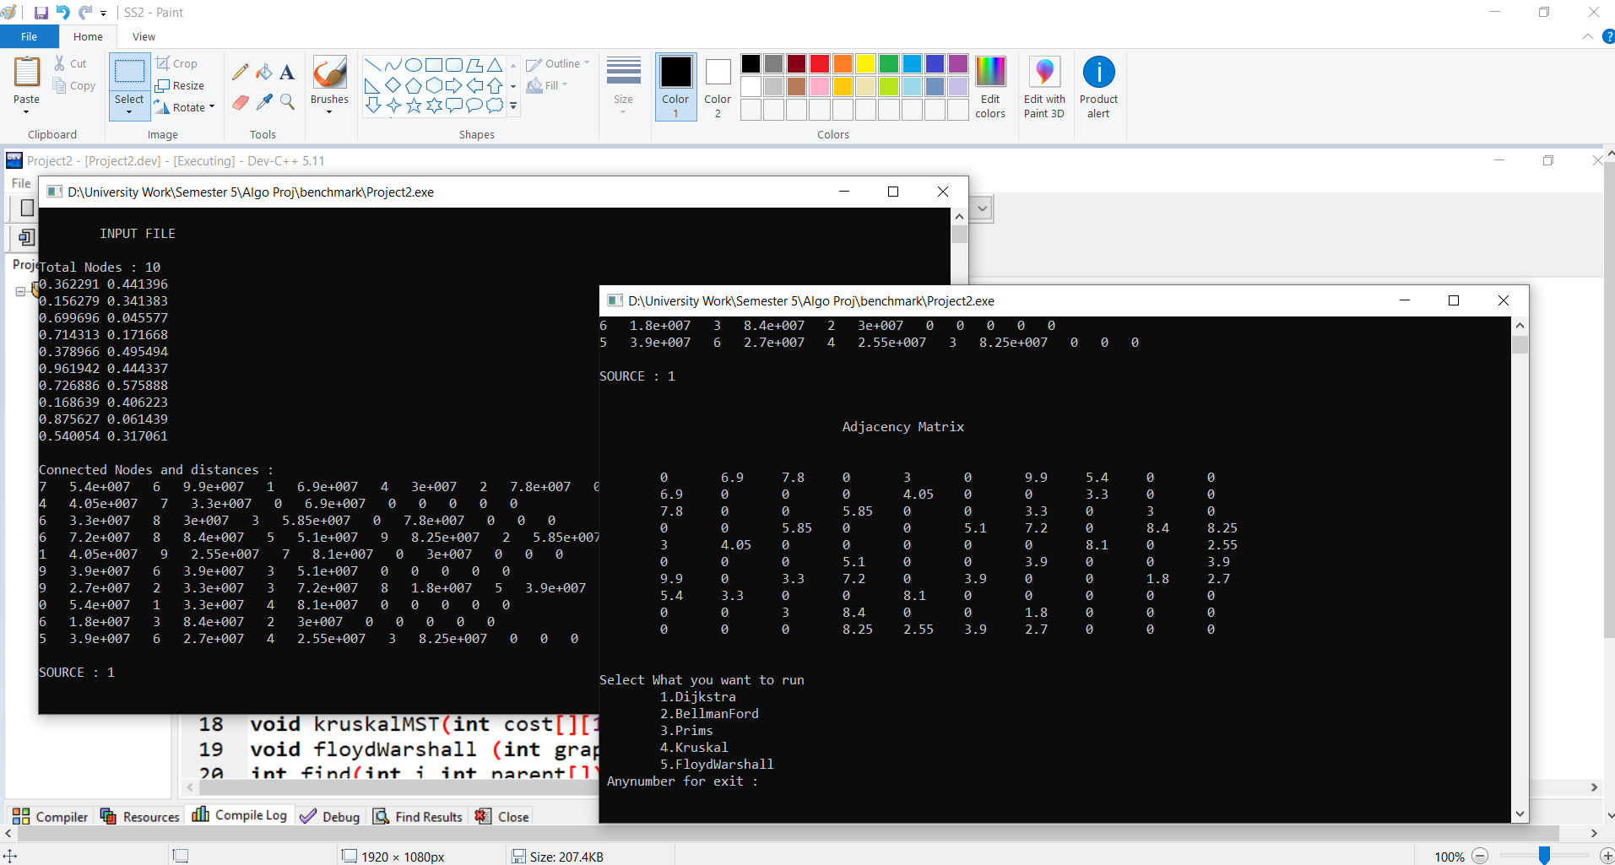

Then it will show the graph and output nodes and costs

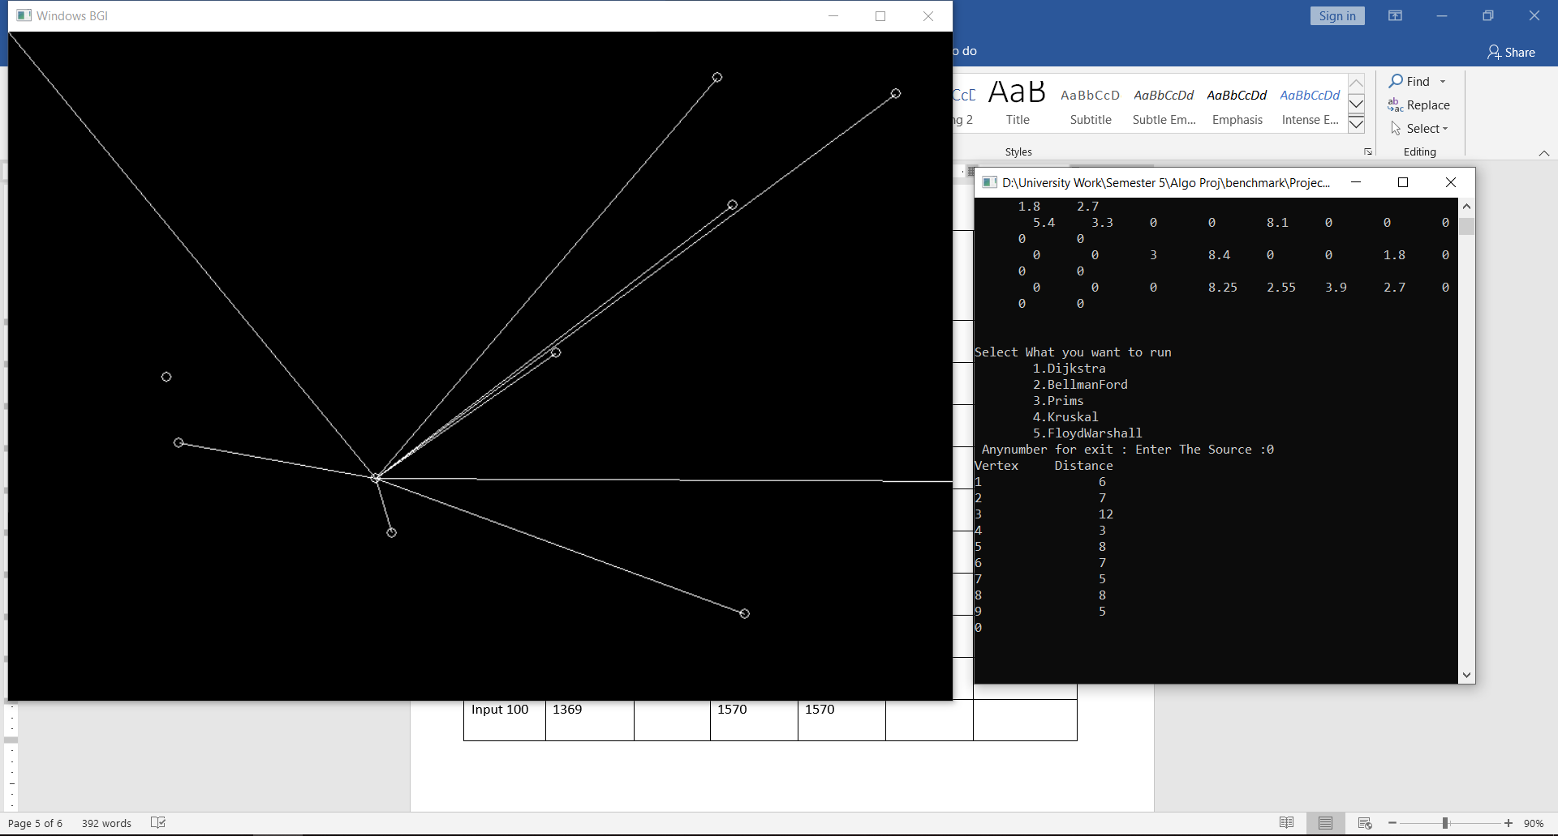

(The below picture shows the graph of 100 inputs of prims)

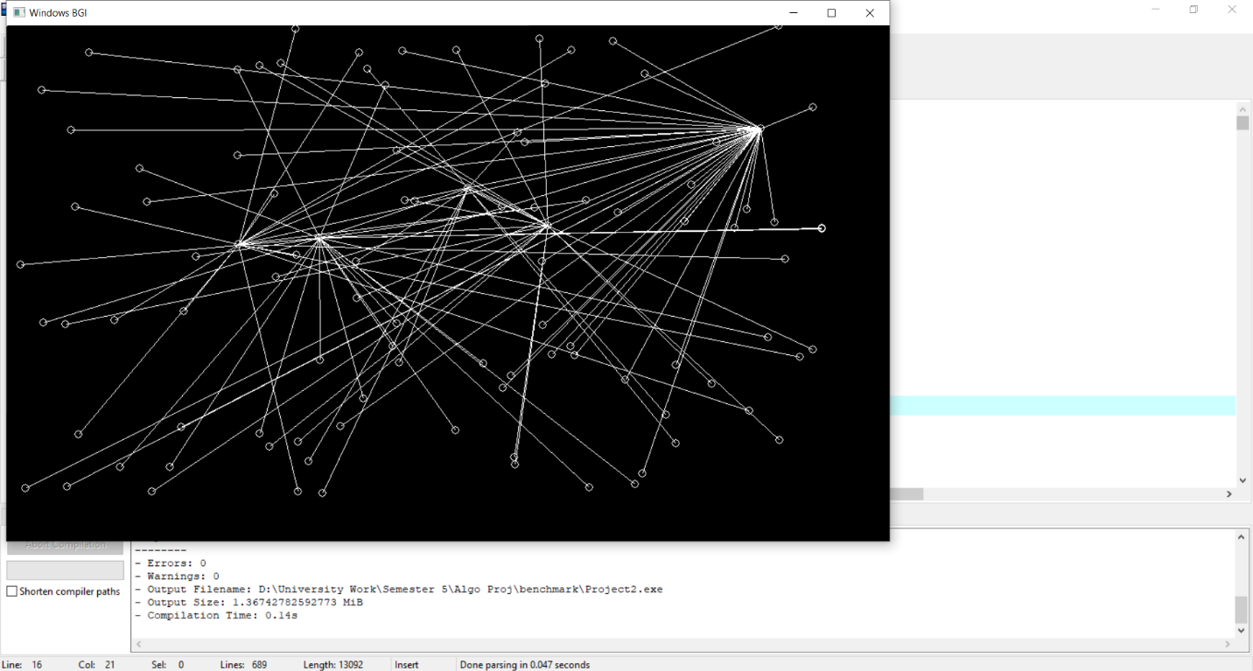

**RESULTS AND DISCUSSION**

|  |  |  |  |  |  |  |
| --- | --- | --- | --- | --- | --- | --- |
| Benchmark | Prims Total cost in Mbps | Kruskal  Min Cost | Dijkstra | Bellman Ford | Floyed Warshall Algorihtm | Clustering Coefficient (Local Clustering) |
| Input 10 | 26 | 26 | 61 | 61 |  |  |
| Input 20 | 72 | 72 | 116 | 116 |  |  |
| Input 30 | 316 | 316 | 214 | 214 |  |  |
| Input 40 | 719 | 719 | 447 | 447 |  |  |
| Input 50 | 934 | 934 | 431 | 431 |  |  |
| Input 60 | 1162 | 1162 | 643 | 643 |  |  |
| Input 70 | 1204 | 1204 | 776 | 776 |  |  |
| Input 80 | 1610 | 1610 | 756 | 756 |  |  |
| Input 90 | 1812 | 1812 | 1098 | 1098 |  |  |
| Input 100 | 1369 | 1369 | 1570 | 1570 |  |  |

**References**

<https://www.geeksforgeeks.org/>